**Project 1 Commentary – Accelerometry Datalogger**

Member: Ye Yuan, Erik Moraru

On November.5th Erik and I recorded the data for this project. We start from the entrance of CSH building and walked to bus stop, then hit on the bus and recorded the whole data for a circle. We used negative y through this recording, that’s why the data are in the negative side most of the time. In this 42 minutes session we recorded 360 data in a 7 seconds period. In the 7 seconds, there are 2 seconds for data collecting and writing to the sd card; 0.5 seconds for the green led lighting up; and 4.5 seconds for receiving the halt signal.

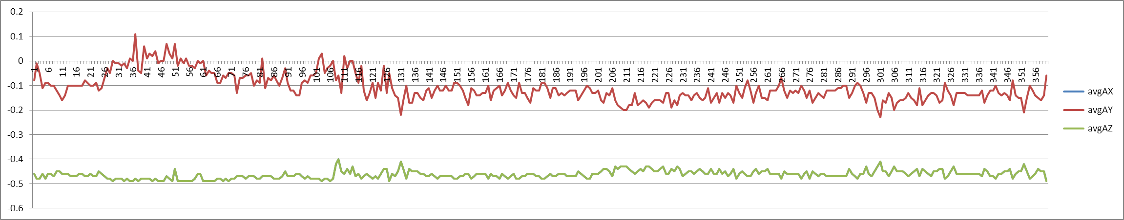

Above is the graph for accelerometer. Because I made a mistake in the sketch, incremented the value of ax to the totalAZ, so in the graph the average of ax and az are the same. Through 0 to 121 are the data before we get on the bus. The reason there is a period the data is positive is because I changed my hand to hold the device several times which changed the direction to positive y axis and so the device collected the data on that way. Then around the sequence 121 we hit on the bus. That’s why the acceleration started increasing hugely at sequence 131 when it started. I believe the bus stop at sequence 151, 206, 266, 296, 326, 346 and 356.

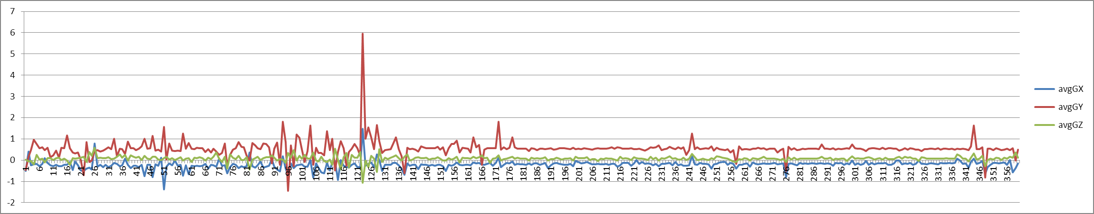

In the second graph, this is the geometry. Before we get on the bus we were constantly moving, that’s why the line is very unstable. It increased very hugely because I handed the device to Erik. After 161, the device was holding relevant stable. The data changed at sequence 171, 176, 241, 256, 276, 345 because the bumping of the bus. Then at sequence 356 we were off the bus.

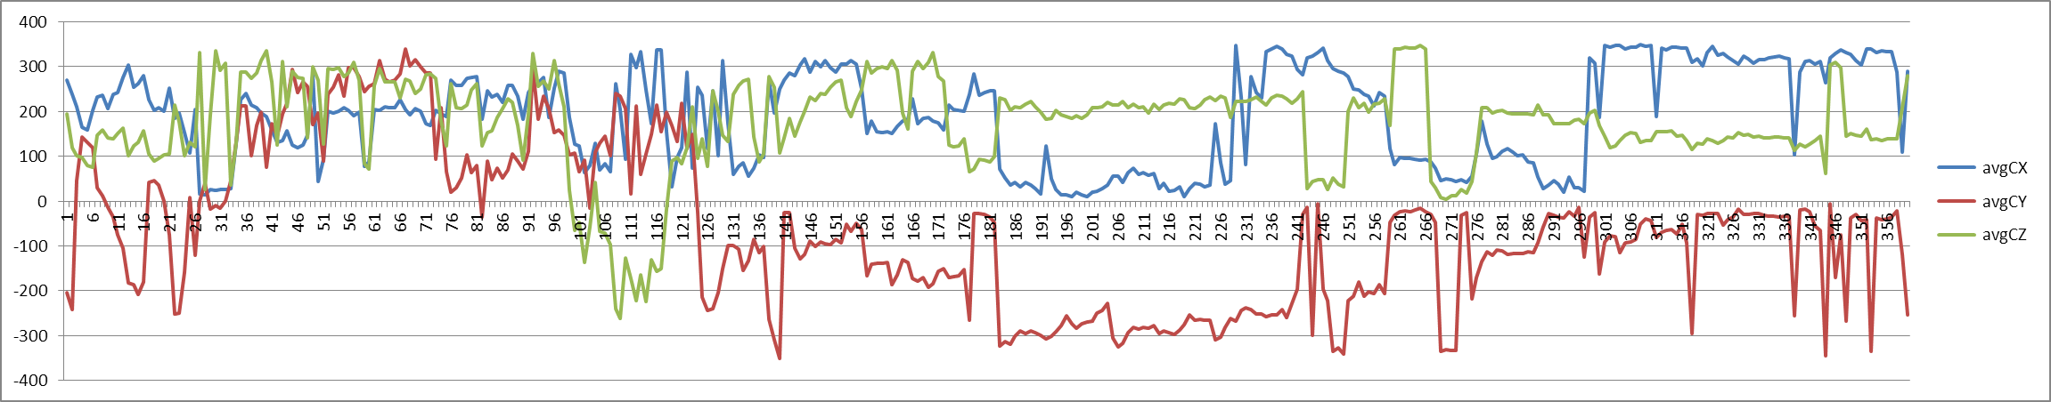

We turned on the device at the door of our faculty, and then we turned left and walked to main road, that’s when the compass increase at first few sequences. We then turned right at the main road and walked to student center, so the value is changing to the positive. From 26 to 121 I believe I change the direction of the device, that’s why they are positive. After we sited on bus, the device was turned to the negative side of y axis again. We were moving to north at sequence 136, 141, 176, 241, 246, 251, 266, 271… so on that the values were around 0 or 360. And South around the sequences around 180. East around 90, West around 270.